**TUGAS 10**

**MATA KULIAH ALGORITMA DAN DASAR PEMROGRAMAN SEMESTER GENAP TAHUN AKADEMIK 2023-2024**



**Oleh:**

**DEVA FAROIDL**

**4123004**

**PROGRAM STRATA-1 JURUSAN SISTEM INFORMASI**

**UNIVERSITAS PESANTREN TINGGI DARUL 'ULUM JOMBANG**

**2024**

LATIHAN:

Source code

package pkg10;

/**

*

* @author

*/

public abstract class Binatang {

public void bernafas(){

System.out.println("semua binatang bernafas");

}

public void makan(){

System.out.println("semua binatang makan");

}

public void berkembangBiak (){

System.out.println("burung berkembang biak dengan cara bertelur");

}

}

class Burung extends Binatang{

public void makan(){

super.makan();

System.out.println("burung makan biji-bijian");

}

public void berkembangBiak (){

System.out.println("burung berkembang biak dengan cara bertelur");

}

}

class Mamalia extends Binatang{

public void berkembangBiak (){

System.out.println("mamalia berkembang biak dengan cara melahirkan");

}

}

class TestAnimal {

public static void main(String args[]){

Binatang lovebird = new Burung();

Binatang cat = new Mamalia();

Mamalia dolphin = new Mamalia();

lovebird.bernafas();

lovebird.makan();

lovebird.berkembangBiak();

cat.bernafas();

cat.makan();

cat.berkembangBiak();

dolphin.berkembangBiak();

}

}

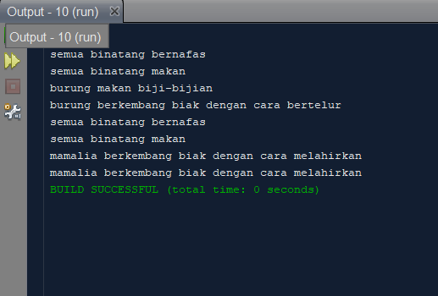

TUGAS :

Source code :

package pkg10;

/**

*

* @author

*/

public abstract class Weapon {

protected int ammo;

public abstract void attack();

public int getAmmo() {

return ammo;

}

}

class Knife extends Weapon {

public Knife() {

ammo = 0; // Knife has no ammo

}

@Override

public void attack() {

System.out.println("Menyayat dan menusuk musuh");

}

}

class Gun extends Weapon {

public Gun(int ammo) {

this.ammo = ammo;

}

@Override

public void attack() {

if (ammo > 0) {

System.out.println("Menembakkan peluru");

ammo--;

System.out.println("Sisa peluru: " + ammo);

} else {

System.out.println("Peluru habis!");

}

}

}

class TestAbstract {

public static void main(String args[]) {

Knife weapon = new Knife();

Knife knife = new Knife();

Gun gun = new Gun(10);

knife.attack();

gun.attack();

gun.attack();

Knife knife2 = new Knife();

Gun gun2 = new Gun(10);

knife2.attack();

gun2.attack();

gun2.attack();

}

}

